SOCIAL REPUBLIC OF VIETNAM
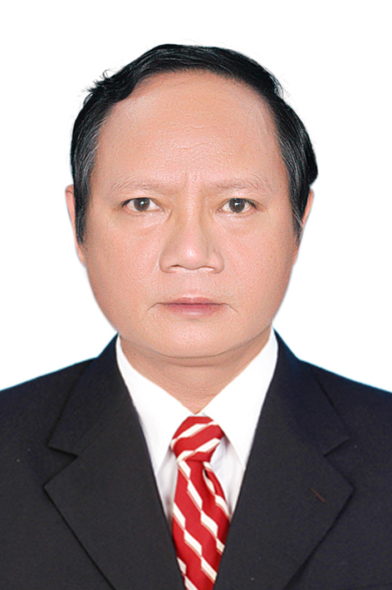
Independence - Freedom - Happiness

CURRICULUM VITAE
- PERSONAL INFORMATION
Full name: LÊ TIẾN DŨNG
Date of birth : 03-May-1962
Address: 355 Tran Hung Dao, Ward 10, District 5, Ho Chi Minh City
Place of work: University Medical Center, District 5, Ho Chi Minh City
Address: 215 Hong Bang Street, District 5, Ho Chi Minh City
Current position: Head of Respiratory Department, University Medical Center
Phone: 0962 265 264 Email: ledungcuc@yahoo.com
- EDUCATION
Periods | Academic title – Position – Working place
1980 – 1986  1986 – 1990  1990 – 1992  1992 – 2001  2001 – 2012  2012 – 2014  2014 – 2016  2016 – present | Student of Faculty of Medicine at Ho Chi Minh City University of Medicine and Pharmacy  Resident physicians Cho Ray Hospital  Physician at Nguyen Tri Phuong Hospital, District 5, HCMC  Master of Medicine – Vice head of Respiratory Department at Nguyen Tri Phuong Hospital, District 5  PhD. Doctor - Head of Respiratory Department at Nguyen Tri Phuong Hospital, District 5  Director of City International Hospital, Binh Tan District  Head of Respiratory Department at Ho Chi Minh University Medical Center  A/prof. Doctor - Head of Respiratory Department at Ho Chi Minh University Medical Center

- THESIS
PhD of Medicine Year : 2000
Thesis: "Evaluate the value of computed tomography in the diagnosis of primary bronchial lung cancer"
A/prof. of Medicine Year: 2016
- SCIENTIFIC BOOKS
- 2009, Medicine publisher, “Guide to practice internal medicine of lung disease”
- 2012, Medicine publisher, “Guideline for handling non-tuberculosis lower respiratory infections”
- 2015, Medicine publisher, “National guidelines for managing asthma and chronic obstructive pulmonary disease”
- 2017, Medicine publisher, “Recommendations for diagnosis and treatment of invasive fungal infections”
- OTHER TASKS
- Visiting staff of Ho Chi Minh City University of Medicine and Pharmacy, Department of Internal Medicine: participating in theoretical and clinical teaching for Master students
- Visiting staff Pham Ngoc Thach Medical University, Department of Internal Medicine: participating in theoretical and clinical teaching for Master students.
- Clinical teaching for international students.
- As the main instructor of 6 Master's medical thesis
- Head of scientific research project: 07
- Science reporting at local and abroad conferences.
- ASSOCIATIONS
- Vice president of Ho Chi Minh City Respiratory Association
- Member of Vietnam Association of Respiratory
- Member of the Executive Board of the Association of Tuberculosis and Lung Disease in Ho Chi Minh City
- Member of the Executive Committee of Vietnam Lung Association
- Member of Ho Chi Minh City Internal Medicine Association
- Member of Asian Network for Surveillance of Resistant Pathogens (ANSORP); Asia Pacific Respiratory Association (APSR); European Respiratory Association (ERS); American Chest Association (ATS).
- PUBLISHED STUDIES
Nearly 30 domestic and foreign scientific research projects on lung cancer, CT scan features in diagnosis of lung cancer, pathological anatomical characteristics in lung cancer, community acquired pneumonia, microbiological characteristics and antibiotic resistance in community acquired pneumonia, hospital acquired pneumonia, microbiological characteristics and antibiotic resistance in hospital acquired pneumonia, value of scales to assess pneumonia, and values of markers in pneumonia, and COPD, microbiological characteristics and antibiotic resistance in COPD, asthma...

